How to Confirm an ICE Raid or Enforcement Activity
A Guide for Advocates & Community Members

With the onset of raid and enforcement operations by the Department of Homeland Security (DHS), we have seen fear and panic spread quickly throughout immigrant communities nationwide, resulting in numerous unconfirmed rumors about ICE in their respective communities. Immigrants’ daily lives have been disrupted, as many around the country have reported being afraid to send their children to school or to shop at the local grocery store.

For these reasons, we are creating a short questionnaire that advocates and community members can use to confirm ICE raids and help dispel inaccurate information that is being spread throughout the community. We advise that advocates try to get answers to all the questions below before posting anything on social media.

- Who did you hear this incident from?
Note if it was word of mouth, media, social media (i.e. Facebook/ Twitter).
*If it was social media posting, contact the original poster and get more concrete details.*

- Are there any photos or evidence of the enforcement operation?
(e.g. pictures of ICE buses, agents etc..)

- Where did the incident occur?
Be as detailed as possible and try to get an address. If there advocates in the area, drive to the location and see if there is any lingering ICE activity.

- Did any of the incidents occur in a place of worship, school, or hospital?
ICE issued a memorandum in 2011 indicating that apart from rare circumstances such as a national security or terrorism matters, it would not engage in enforcement operations within these sensitive locations. https://www.ice.gov/doclib/ero-outreach/pdf/10029.2-policy.pdf

- What time of the day did the incident take place?

- Who were the individuals affected in the raid? How many?

Get more information about those affected:
  - How old were they?
  - When did they come to the U.S.?
  - Did any of them apply for political asylum? On what basis?
  - Were they represented by a lawyer in their fight for asylum? If not, did they ask for a lawyer?
  - Did they ever appear before a judge? If so, when?
  - Were the ordered removed by an immigration judge?
  - Did they sign any voluntary departure papers?
  - Had they received any other warnings or order to report prior to the raids?
  - Have any of them been convicted of a crime? If so, what were the convictions?
  - Do they have family in the US?

- Who else was present during the raid? Were there children present? How old? How were they treated?

- Which agency/agencies took part of the operation?
(e.g. ICE, Sheriffs, etc.)

This image shows the differences between agencies.
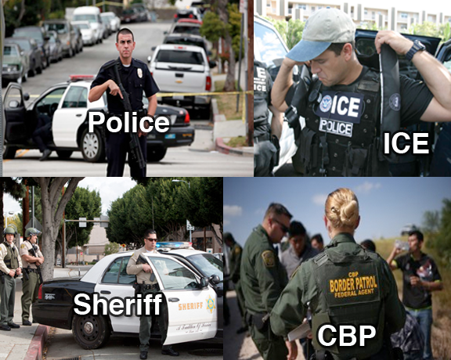

If it was ICE:

  - Did ICE enter the home? If so, did the occupants provide consent for them to enter?
  - Did ICE show a warrant? Was it signed by a Judge?
  - Who was specified on the warrant, was it for that address? Did you get a copy?

  - Did ICE try to seek consent to a search in the language of the individuals in the residence? Did they have officers present who spoke that language?
  - Did ICE enter any part of the house or property (ex. front yard, backyard) without the resident’s consent?
  - Did ICE enter the neighboring houses on the claims of safety for their officers?
  - Did ICE focus its immigration status questioning – and arrests – only on the individuals named on the warrant? Or were other individuals swept up into questioning and arrests? (i.e. collateral arrests)

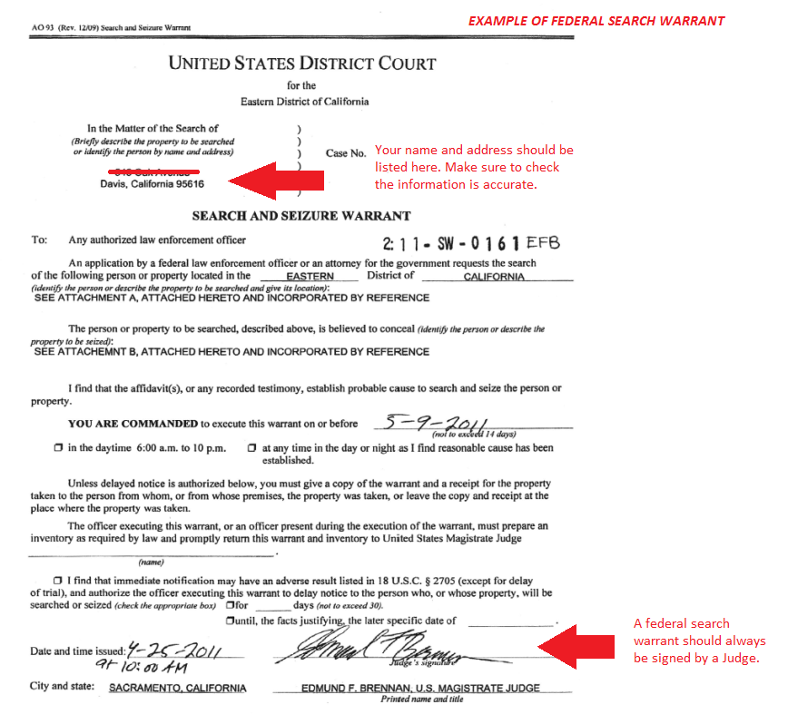

Additional Follow Up:

If the incident took place at a specific location (warehouse, supermarket, school), call the facility and get more information. *It helps if you talk with administrators, managers, or other higher-ups.*

If you have good relationships with your local officials, police or ICE field office, give them a call to try and confirm the enforcement operations. Alternatively, you can request your local congressional representative’s office to submit an inquiry to ICE about any operations you may have heard of.

Please send a copy of the intake to the information below, so we can collect information about enforcement for possible legal action and assist the community with Know Your Rights information.

ACLU of Arkansas
904 West 2nd Street, Suite 1
Little Rock, AR 72201
www.acluarkansas.org

February 2017

